Tillage

## Boarder Disc / Disc Ridger

**Category:** Tillage Implement

**Tag:** Tractor Mounted Tillage

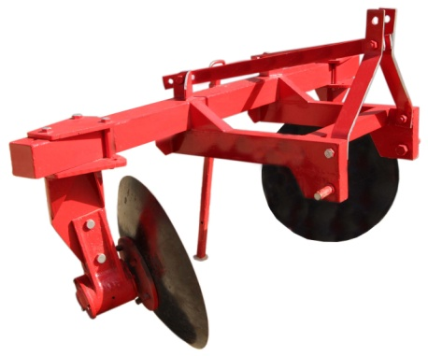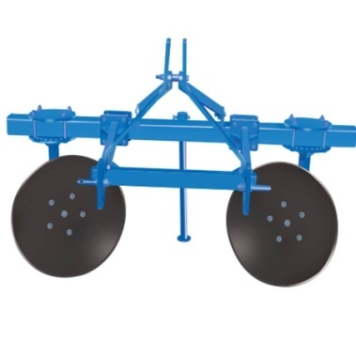

Implement used to make boundaries and irrigation ridges.

## Description

A tractor mounted implement ideal for your farm to make

* Field Boundaries
* Temporary irrigation ridges and
* Levies for Checking Soiled and Water Erosion

Can also be used to uproot crops sown in rows. E.g. Potatoes

The size and shape of bunds/ridges can be varied simply by repositioning the disc clamps on tool bar and rotating the disc bodies relative to clamps. It has heavy duty box type frame. The size and depth of the ridge can be adjusted.

Heavy duty tubular Square Section tool bar can make up to 18” high boundary

|  |  |
| --- | --- |
| Specifications | |
| Disc Size | 28’’ diameter |
| Disc Angle | Tilt adjustable |
| Border width | Adjustable |
| Linkage | Three points |
| Type of discs | Plain or notched (Optional) |
| Bearing Hubs | 2 |
| Number of discs | 2 |
| Width | 84’’ |
| Length | 30’’ |
| Height | 48’’ |
| Weight (aprox) | 211 KG w/o discs |
| Tractor Compatibility | 50 - 55 HP |

## Chisel Plough

**Category:** Tillage Implement

**Tag:** Tractor Mounted Tillage

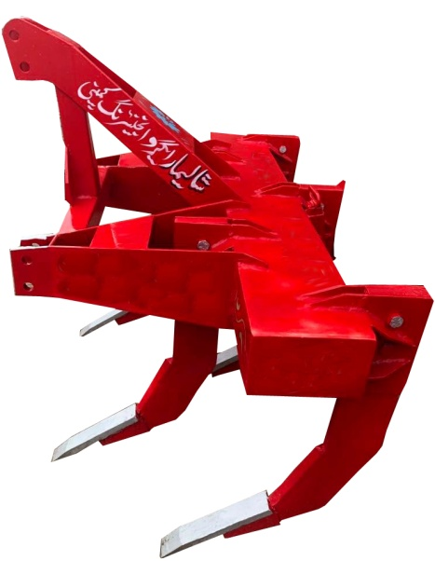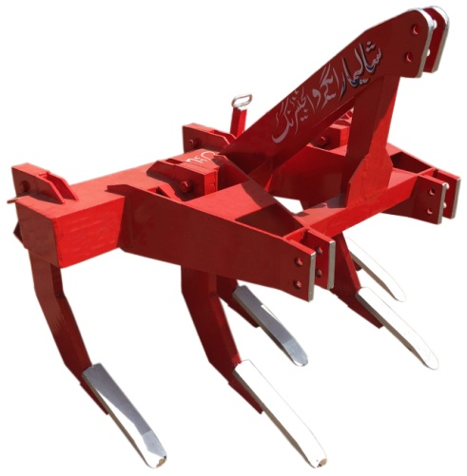

Primary Tillage Implement for Deep Tillage used in Soil Preparation.

## Description

* Works deep beneath the surface. Ideal when topsoil is fertile but subsoil is not productive
* Shatters the soil well below the surface
* Does not invert of turn the soil, causing limited soil distribution
* Loosen and aerate soil, leaving crop residue at top of soil
* Reduces the effect of Compaction
* Help break-up hardpan
* Removing the side shanks turns this implement into a sub soiler
* Replaceable Shanks/Points
* Depth can be adjusted by top links
* Adjustable depth & width of ploughing available for 3 & 5 arm sub-soiler
* Shovels easily replaceable
* Optional wide range of roller available

|  |  |  |
| --- | --- | --- |
| Specifications | | |
|  | 3 Tyne | 5 Tyne |
| Width | 45’’ | 74’’ |
| Length | 39’’ | |
| Height | 52’’ | |
| Max. Working depth | 12’’-15’’ | |
| Weight (aprox) | 261 KG | 375 KG |
| Tractor Compatibility | 50-65 HP | 65-85 HP |

## Cultivator

**Category:** Tillage Implement

**Tag:** Tractor Mounted Tillage

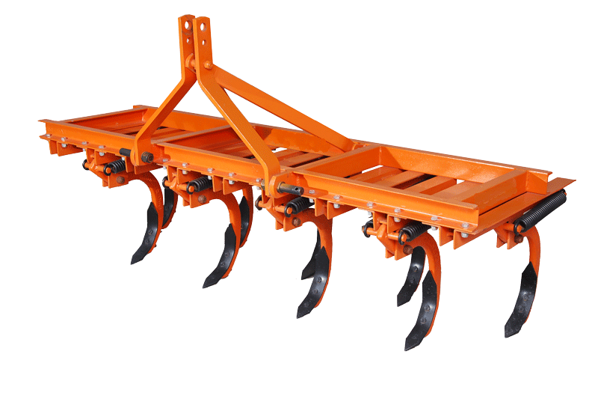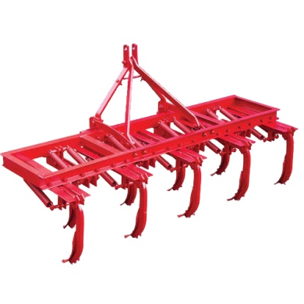

Tine Tiller  
Secondary Tillage Implements  
Used for Preparation of Seedbed

## Description

* Operation similar to chisel plough – but different goals
* Used to ‘Complete’ Tillage operations
* Works near the surface and disturbs the soil in careful pattern by producing staggering pattern
* Stir and pulverize the soil. (aerate the soil – before planting; weed control – after planting)
* Preparation of proper seedbed, burying the crop residue, warming the soil
* Mix and incorporate the soil to ensure growing crop has enough water and nutrition
* Consequently cultivating takes less power per shank than chisel plough

|  |  |  |  |
| --- | --- | --- | --- |
| Specifications | | | |
|  | 9 Tynes | 11 Tynes | 13 Tynes |
| Width | 90’’ | 96’’ | 102’’ |
| Length | 44’’ | | |
| Height | 45’’ | | |
| Cultivating Width | 84’’ | 90’’ | 96’’ |
| Max. Working depth | 7’’ | | |
| Weight (aprox) | 305 KG | 334 KG | 365 KG |
| Tractor Compatibility | 50 HP | 60 HP | 65  – 85 HP |

## Ditcher Plough / Canal Opener Ridge Plough

**Category:** Tillage Implement

**Tag:** Tractor Mounted Tillage

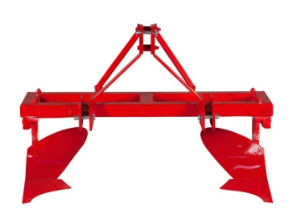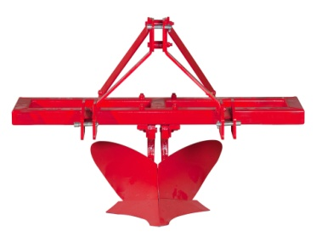

## Description

Canal Opener Ridge Plough

* Primary Purpose to make water channels, open furrows and make ridges between rows and ridging for row planted seeds such as; maize, sunflower, cotton, etc
* Open Furrows as demanded up to 27’’
* Interchanging the Mouldboards will turn this implement into a single ridger

|  |  |
| --- | --- |
| Specifications | |
| Number of Tynes | 2 |
| Width | 66’’ |
| Length | 30’’ |
| Height | 52’’ |
| Weight (aprox) | 205 KG |
| Tractor Compatibility | * 1. P |

## Tandem Disc Harrow

**Category:** Tillage Implement

**Tag:** Tractor Mounted Tillage

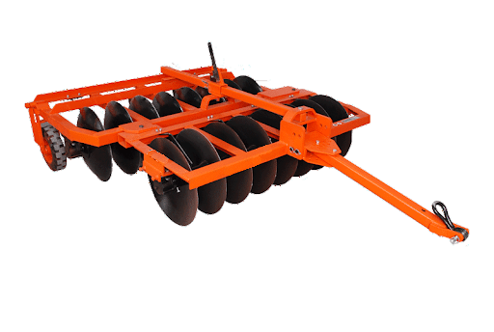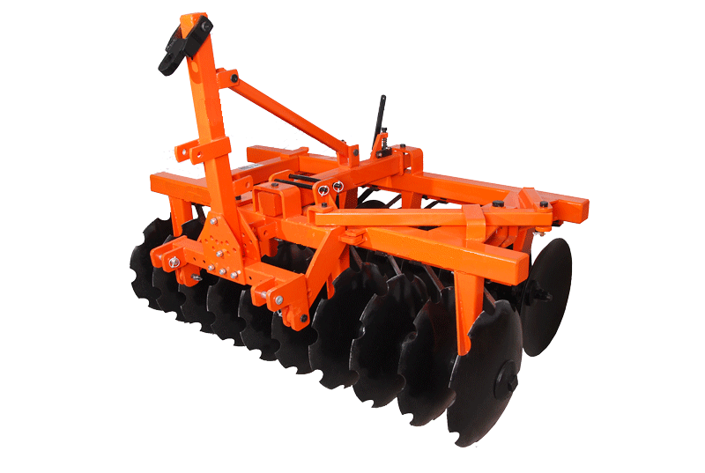

## Description

* It has a strong and sturdy main frame with Boron steel discs
* Heavy duty cast iron spools to provide centre weight
* High soil disturbance
* Good handling of obstacles
* Breaking of large clods – harrowing after ploughing
* Chopping and mixing crop residues into the soil
* Preparation of seedbed
* Wheels can be provided for easy transportation (optional)

|  |  |  |  |
| --- | --- | --- | --- |
| Specifications | | | |
|  | 14 Discs | 16 Discs | 18 Discs |
| Width | 96’’ | 102’’ | 108’’ |
| Length | 137’’ | | |
| Height | 34’’ | | |
| Disc Diameter | 24’’ | | |
| Tyre size | 600 - 16 | | |
| Bearing Hubs | 2 | | |
| Tractor Compatibility | 50 HP | 60 HP | 65    - 85 HP |

## Rotary Tiller / Rotavator

**Category:** Tillage Implement

**Tag:** Tractor Mounted Tillage

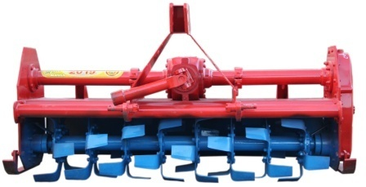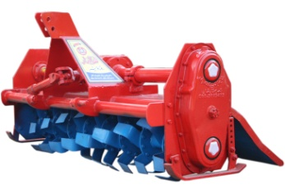

## Description

* Curved blades slice through the soil
* Chop surface residue
* Mix all material in the disturbed layer
* Pulverize the soil and buries weeds and crop residue
* Heavy duty side gear drive in oil bath which ensures high performance in all working conditions
* Helical arrangement of the blades puts fewer loads on the tractor which makes tillage fast and economical
* 6 Blades on each flange
* Available in 6 to 9 flanges plough
* 8 inches flange to flange distance
* Heat treated blades
* Durable against torque and stress
* Smooth, efficient power transmission and superior durability
* Grease fittings on driveline and rotary shaft
* Can loosen & aerate soil up to 5 inches deep

|  |  |  |  |  |
| --- | --- | --- | --- | --- |
| Specifications | | | | |
| Number of cutters | 36 | 42 | 48 | 54 |
| Width | 38’’ | | | |
| Length | 67’’ | 75’’ | 82’’ | 90’’ |
| Height | 39’’ | | | |
| Weight (aprox) | 445 KG | 483 KG | 493 KG | 540 KG |
| Tractor Compatibility | 50 HP | 60 HP | 75 HP | 75 - 85 HP |

## MB Plough

**Category:** Tillage Implement

**Tag:** Tractor Mounted Tillage

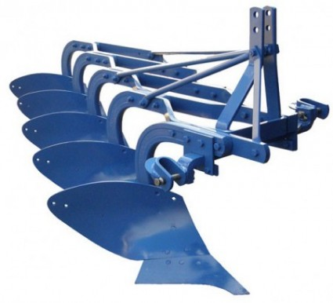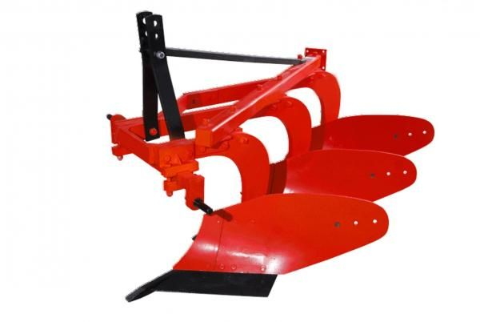

Primary Tillage Implement for Preparation of Soil

## Description

* Right handed bottoms – Turns the soil to the right
* Used where soil inversion is necessary
* Completely inverts a layer of soil to bury surface materials & pulverize the soil
* Most important implement for areas with too much weed – Canal irrigated or rain fed areas
* Least damage to soil structure
* The plough has special wear-resistant steel blade with bar points for toughest ploughing jobs
* Bar points having longer life, as they can be extended till the last possible length
* It is designed to work in all types of soil, for soil breaking, soil raising and soil turning

|  |  |  |
| --- | --- | --- |
| Specifications | | |
|  | 3 Tyne | 5 Tyne |
| Width | 39’’ | |
| Length | 51’’ | 84'' |
| Height | 45’’ | |
| Depth of Cut | 14'' | |
| Width of Cut | 40'' | 52'' |
| Tractor Compatibility | 65 HP | 85 HP |

## Ridger plough

**Category:** Tillage Implement

**Tag:** Tractor Mounted Tillage

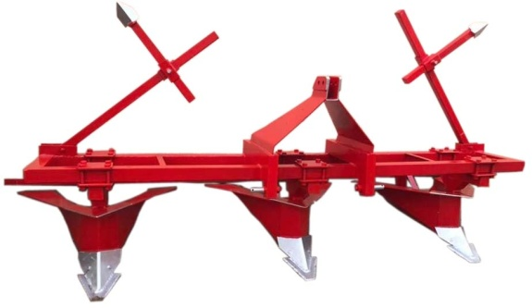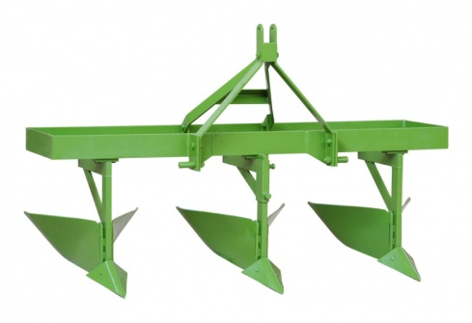

Performs Shallow Tillage Operation  
For preparation of seedbed and earthing of crops

## Description

* Two Mould Boards – Turning soil to left and right
* To split fields into ridges/furrows and earthing up crops
* Broader bed, accurate row width & Ideal for row crops
* Disturbs the top surface of the soil
* It is mostly used for making ridges for plantation of vegetable, cotton, sugarcane etc
* It has heavy duty box type frame

|  |  |  |  |  |  |  |
| --- | --- | --- | --- | --- | --- | --- |
| Specifications | | | | | | |
|  | 2 Tyne | 3 Tyne | 4 Tyne | 7 Tyne | 9 Tyne | 10 Tyne |
| Width |  | 118'' |  |  | 91'' |  |
| Length |  | 42’’ |  |  | 42'' |  |
| Height |  | 38’’ |  |  | 54'' |  |
| Depth of Cut |  | 12’’– 14’’ |  |  | 8'' |  |
| Width of Cut |  | 21’’– 27’’ |  |  | 12'' -15'' |  |
| Tractor Compatibility | 50 HP | 50 HP | 60 HP | 65 HP | 65-75 HP | 85 HP |

## Furrows

**Category:** Tillage Implement

**Tag:** Tractor Mounted Tillage

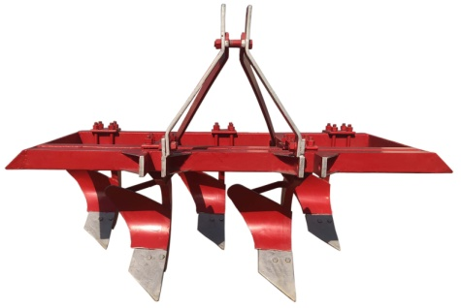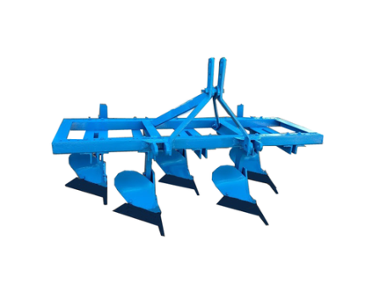

## Description

* A Primary tillage implements ideally suited for shallow or Surface ploughing, but with a Larger and better ploughing capacity
* Strong and study construction
* Three point mounting on tractor
* Simple and easy to operate
* Provided with spring steel cutting blades

|  |  |  |
| --- | --- | --- |
| Specifications | | |
|  | 5 Tyne Square Frame | 5 Tyne  Long  Frame |
| Width | 66'' | 78’’ |
| Length | 46'' | |
| Height | 45’’ | |
| Depth of Cut | 10’’- 12'' | |
| Width of Cut | 6-8'' | |
| Tractor Compatibility | 75 HP | |

## Stubble Slasher / Shaver Cutter

**Category:** Tillage Implement

**Tag:** Tractor Mounted / PTO Operated Tillage

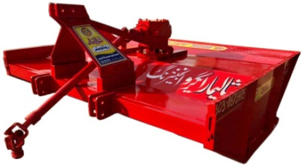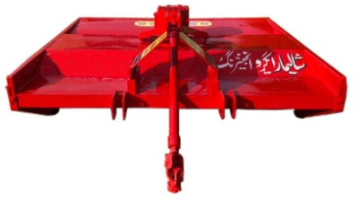

## Description

* Multi crop Stubble Slasher is foremost equipment for cultivation
* It is used immediately after harvesting and prior to soil becoming dry
* Stubble slasher blades cuts unwanted weeds
* It can shred brush and shakes of all kinds of crops, cotton, tomato, tobacco, maize & others
* Optional depth control system
* Working Efficiency: 1 acre in 1 hour

|  |  |
| --- | --- |
| Specifications | |
| Blades | 2 |
| Blade size | 18'' x 8'' x 4 MM |
| Width | 90’’ |
| Length | 72’’ |
| Height | 42’’ |
| Speed of blades | 1000 - 1100 rpm |
| Working width | 52'' |
| Tractor Compatibility | 60 - 75 HP |

## Disc Plough

**Category:** Tillage Implement

**Tag:** Tractor Mounted Tillage

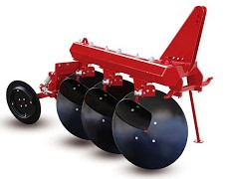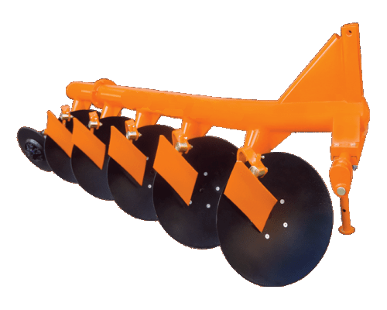

Performs Soil Turning, Soil Breaking and Soil Raising.

## Description

* Deep Ploughing in root-infested, sticky, stony and hard soils
* Turns the furrow slice to one side in ‘Scooping Action’
* Mixes remains of crops and weeds throughout the depth of ploughing
* Ideal for rain-fed areas for checking soil erosion by water and wind
* Also works very well in stone free lands
* Follow-up with secondary tillage (harrowing) not necessary as compares to Mould Board Plough
* Handles obstacles much easily
* Requires less power

|  |  |  |  |
| --- | --- | --- | --- |
| Specifications | | | |
|  | 2 Discs | 3 Discs | 4 Discs |
| Axle type | Spindle | | |
| Drawbar type | Hexagonal / Round | | |
| Disc type | Notched / Plain | | |
| Disc Diameter | 28'' | | |
| Disc Spacing | 23'' | | |
| Bearing Hubs | 2 | 3 | 4 |
| Tractor Compatibility | 50 - 60 HP | 65 - 75 HP | 85 HP |